**Assignment – 5: Relational and Logical Operators**

1. Write a query that will give you all orders for more than Rs. 1,000.

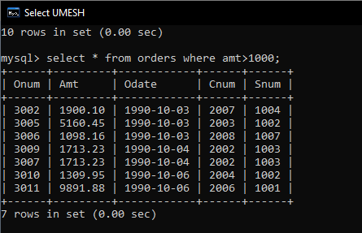

1. Write a query that will give you the names and cities of all salespeople in London with a commission above .10.

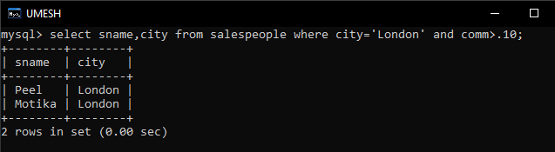

1. Write a query on the Customers table whose output will exclude all customers with a rating <= 100, unless they are located in Rome.

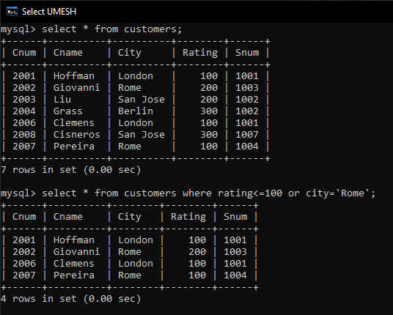

1. What will be the output from the following query?

Select * from Orders where (amt < 1000 OR NOT (odate = ‘1990-10-03’ AND cnum> 2003));

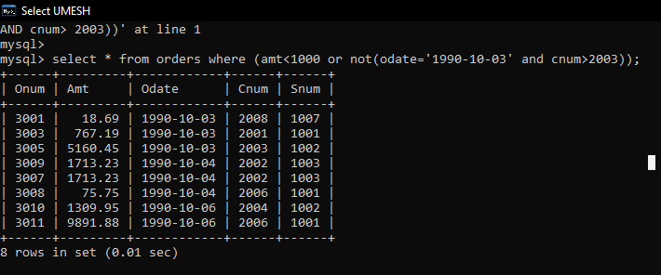

*This query will return all orders where either the amount is less than Rs. 1,000 or the order date is not '1990-10-03' with a customer number greater than 2003.*

1. What will be the output of the following query?

Select * from Orders where NOT ((odate = ‘1990-10-03’ OR snum>1006) AND amt >= 1500);

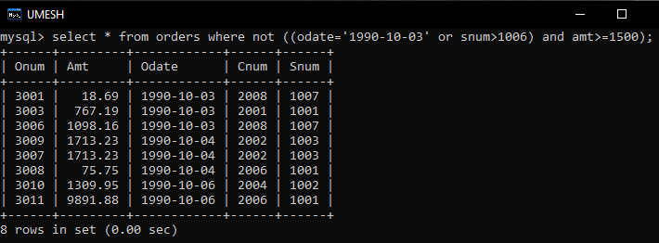

This query will return all orders except those where the order date is '1990-10-03' or the salesperson number is greater than 1006 and the amount is Rs. 1,500 or more.

1. What is a simpler way to write this query?

Select snum, sname, city, comm From Salespeople where (comm > .12 OR comm<.14);

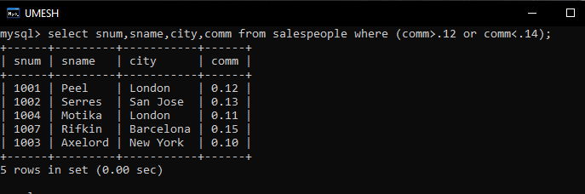

Since the condition comm < 0.14 is unnecessary because it doesn't restrict the result set further, we can simplify it to just check for comm > 0.12.